🎓 GPA Analyzer & Predictor
A Python-based tool for calculating, visualizing, and predicting academic performance using AI and machine learning.

📋 Table of Contents
- Overview
- Features
- Screenshots
- Installation
- Quick Start
- Usage Guide
- Technologies
- Project Structure
- Documentation
- Future Enhancements
- Contributing
- License
- Author

Overview
The GPA Analyzer & Predictor is an intelligent academic performance tracking tool designed for students and registry units. It automates GPA/CGPA calculations, provides visual insights into academic trends, and uses AI to predict future performance and help students plan their academic goals.
The Problem
Students face challenges:
- Manual GPA calculations are tedious and error-prone
- Difficult to visualize academic trends over time
- Hard to plan what grades are needed for target CGPA
- No way to predict future performance based on trends
The Solution
This tool provides:
- Automated GPA/CGPA calculation from CSV files
- Visual trend analysis with interactive charts
- AI-powered scenario predictions
- Goal planning with path-to-target calculator
- Machine learning forecasts

Features
Core Features
GPA/CGPA Calculation
- Converts letter grades (A-F) to grade points (5.0 scale)
- Calculates weighted semester GPA
- Computes cumulative CGPA across all semesters
- Handles multiple semesters automatically
Data Management
- CSV file upload with file browser interface
- Comprehensive data validation
- Clear error messages with fix suggestions
- Supports standard CSV format
Visualization Features
Performance Visualizations
- Line Chart: GPA trend across semesters
- Bar Chart: Semester-by-semester comparison
- Dashboard: Combined view with statistical insights
All charts include:
- Color-coded performance indicators
- Value labels on data points
- CGPA reference lines
- Best/worst semester identification
AI-Powered Features
Scenario Predictor
Predicts future CGPA based on three scenarios:
- Improve: If performance increases
- Maintain: If performance stays consistent
- Decline: If performance decreases
Provides detailed explanations and recommendations for each scenario.
Path to Target Calculator
Calculates exactly what GPA you need to reach your target CGPA:
- Feasibility analysis (is the goal achievable?)
- Difficulty rating (Easy/Moderate/Challenging/Very Difficult)
- Specific strategies and study recommendations
- Alternative suggestions if goal is unrealistic
Machine Learning Predictor
Uses Linear Regression to:
- Learn from your past performance pattern
- Identify trends (improving/declining/stable)
- Forecast next semester GPA
- Visualize predictions vs. actual performance

Screenshots
Dashboard View
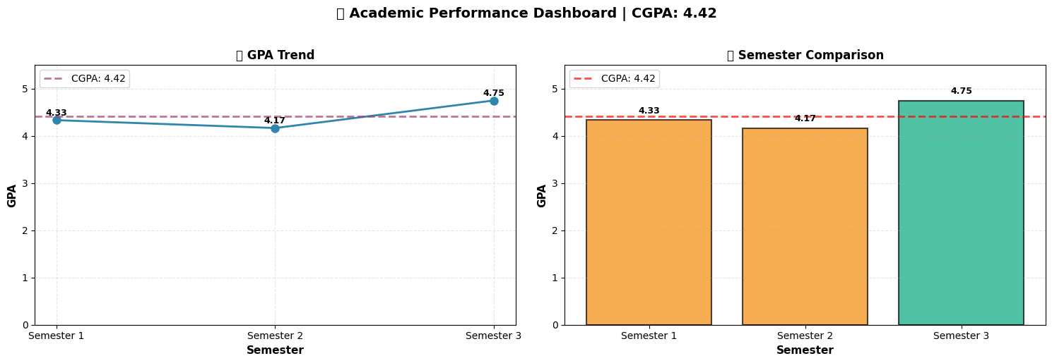
Combined visualization showing GPA trends and semester comparison
AI Scenario Predictions
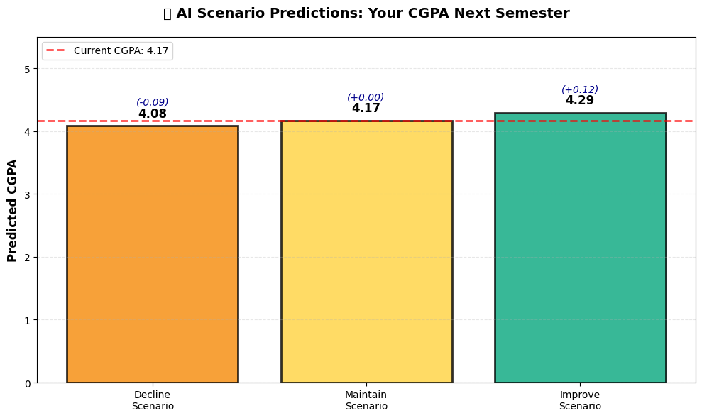
What-if analysis showing three possible futures

ML Forecasting
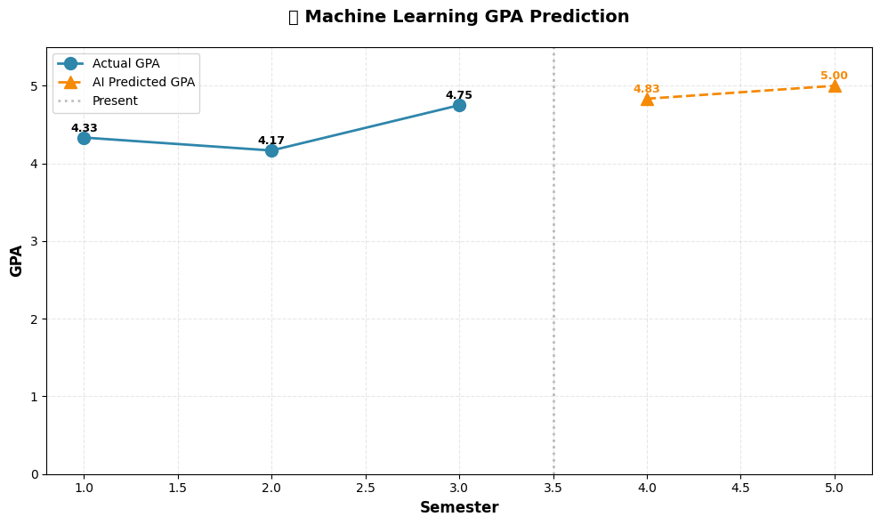
Machine learning forecast based on past performance
Path to Target
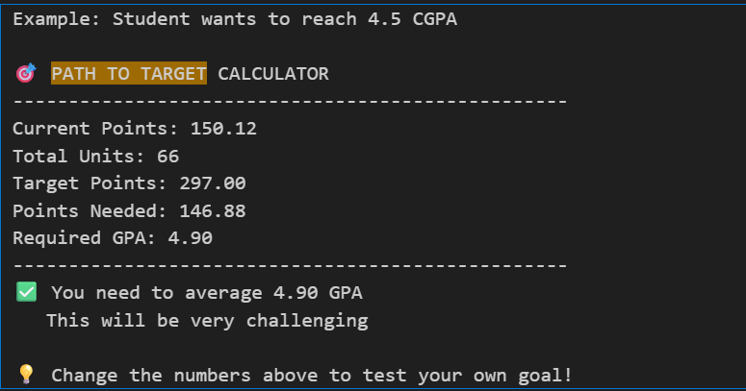
Goal planning with required GPA calculation

Installation
Prerequisites
- Python 3.8 or higher
- pip (Python package manager)
- Jupyter Notebook or JupyterLab
Step 1: Clone the Repository
git clone https://github.com/yourusername/gpa-analyzer.git
cd gpa-analyzer
Step 2: Install Dependencies
pip install -r requirements.txt
Or install manually:
pip install pandas>=2.0.0 matplotlib>=3.7.0 scikit-learn>=1.3.0 jupyter>=1.0.0
Step 3: Launch Jupyter Notebook
jupyter notebook
Step 4: Open the Notebook
Navigate to gpa_calculator.ipynb and open it.

Quick Start
Option 1: Use Sample Data (Fastest)
- Open gpa_calculator.ipynb
- Run all cells (Cell → Run All)
- See results instantly with sample data
Option 2: Upload Your Own Grades
- Prepare your CSV file with format:
- Semester,Course,Units,Grade
- 1,Introduction to Computing,3,A
- 1,Calculus I,4,B
- 2,Data Structures,3,A
- Run Cell 32 (Complete Workflow)
- Select your CSV file when prompted
- View your results!

Usage Guide
Preparing Your CSV File
Your CSV must have exactly these 4 columns:
Column | Type | Example | Notes
Semester | Number | 1, 2, 3 | Semester number
Course | Text | "Mathematics" | Course name
Units | Number | 3, 4, 5 | Credit units/hours
Grade | Letter | A, B, C | Only A-F accepted
Example CSV:
Semester,Course,Units,Grade
1,Introduction to Computing,3,A
1,Calculus I,4,B
1,English Composition,2,C
2,Data Structures,3,A
2,Calculus II,4,A
Running the Complete Analysis
Method 1: Complete Workflow (Recommended)
Run Cell 32 for one-click full analysis:
- Loads and validates your CSV
- Calculates GPA/CGPA
- Generates all visualizations
- Runs AI predictions
- Shows ML forecasts
Method 2: Step-by-Step
Run cells individually to see each step:
- Cells 1-7: Core calculations
- Cells 8-15: CSV loading
- Cells 16-19: Visualizations
- Cells 20-23: AI scenarios
- Cells 24-27: Path calculator
- Cells 28-31: ML predictions
Understanding the Results
CGPA Output:
🎓 YOUR CGPA: 4.17
📚 Semesters: 3
📊 Total Units: 36
⭐ Total Points: 150.00
Visualizations:
- Blue line = Your actual GPA each semester
- Red dashed line = Your CGPA average
- Green bars = Semesters above CGPA
- Orange bars = Semesters below CGPA
AI Predictions:
- Scenario predictor: Shows CGPA if you improve/maintain/decline
- Path calculator: Shows required GPA for your goal
- ML forecast: Predicts based on your specific trend

Technologies
Core Stack
Technology | Version | Purpose
Python | 3.8+ | Programming language
Pandas | 2.0+ | Data manipulation
Matplotlib | 3.7+ | Visualization
Scikit-learn | 1.3+ | Machine learning
NumPy | Latest | Numerical operations
Jupyter | 1.0+ | Development environment
Tkinter | Built-in | File browser UI
Why These Technologies?
Python: Rich data science ecosystem, beginner-friendly
Pandas: Industry standard for data processing
Matplotlib: Mature, customizable visualization library
Scikit-learn: Simple, powerful ML with excellent documentation
Jupyter: Interactive development, combines code and results

Project Structure
gpa-analyzer/
│
├── gpa_calculator.ipynb # Main notebook (37 cells)
├── requirements.txt # Python dependencies
├── README.md # This file
├── sample_grades.csv # Sample data for testing
├── test_bad_grades.csv # Test data for validation
│
├── docs/ # Documentation
│ ├── requirements.md # Requirements document
│ ├── design.md # Design document
│ ├── user_manual.md # User manual (in notebook Cell 35)
│ └── screenshots/ # Screenshots
│ ├── dashboard.png
│ ├── scenarios.png
│ ├── ml_prediction.png
│ └── path_calculator.png
│
└── .gitignore # Git ignore file

Documentation
Available Documentation
- User Guide - In notebook Cell 35 (comprehensive usage instructions)
- Requirements Document - docs/requirements.md (functional & non-functional requirements)
- Design Document - docs/design.md (architecture, algorithms, design decisions)
- Code Comments - Every function has detailed docstrings
- This README - Quick start and overview
Key Algorithms
GPA Calculation:
GPA = Σ(Grade Points × Units) ÷ Total Units
CGPA Calculation:
CGPA = Total Points Earned ÷ Total Units Completed
Path to Target:
Required GPA = (Target Points - Current Points) ÷ Remaining Units
Machine Learning:
- Algorithm: Linear Regression
- Training: Past semester numbers → GPA values
- Prediction: Future semester numbers → Predicted GPA

Future Enhancements
Phase 2 (Post-Initial Release)
- Web Interface: Streamlit-based web app
- API Integration: Claude AI for natural language explanations
- Export Features: PDF report generation
- Enhanced ML: Additional models (Random Forest, Neural Networks)
Phase 3 (Long-term)
- Database Support: PostgreSQL/SQLite integration
- Multi-user System: Authentication and user management
- Mobile App: React Native mobile version
- Institutional Integration: Connect with university systems
- [ ] Peer Comparison: Anonymized benchmarking
- [ ] Course Recommendations: Suggest courses based on performance

Contributing
Contributions are welcome! Here's how:
How to Contribute
- Fork the repository
- Create a feature branch (git checkout -b feature/AmazingFeature)
- Commit your changes (git commit -m 'Add some AmazingFeature')
- Push to the branch (git push origin feature/AmazingFeature)
- Open a Pull Request
Development Guidelines
- Follow PEP 8 style guide
- Add docstrings to all functions
- Include tests for new features
- Update documentation
Bug Reports
Found a bug? Open an issue with:
- Description of the bug
- Steps to reproduce
- Expected vs. actual behavior
- Screenshots if applicable

Author
Hana Kari
Organization: Flexisaf Educational Technology
Project Type: Internship Project - Data Science & Generative AI
Date: December 2025

